Power System Protection Assignment – III (Circuit Breakers Answers)

- Define arcing phenomenon.
The arcing phenomenon occurs when circuit breaker contacts separate during a fault; the insulating medium between them is subjected to extremely high electric stress, leading to its breakdown and the formation of a conducting channel or arc. This arc allows the current to continue flowing between the separated contacts until it is finally extinguished.

- Why is arc extinction easier in AC than DC?
Arc extinction is easier in AC because the current naturally passes through a zero point 100 times per second (at a 50 Hz frequency), providing a natural opportunity for the arc to be extinguished. DC current does not have these natural zeros, so it must be forced to zero by external circuits, which is much more difficult to achieve.

- Define re-striking voltage.
The restriking voltage is the transient voltage that appears across the circuit breaker contacts at the exact instant the arc is extinguished as the current passes through zero.

- What is RRRV?
RRRV stands for the Rate of Rise of Restriking Voltage. It represents how quickly the restriking voltage increases across the contact gap; if this rate exceeds the rate at which the gap recovers its dielectric strength, the arc will strike again.

- What is current chopping? State one disadvantage of current chopping.
Current chopping is a phenomenon where low inductive currents are interrupted abruptly before reaching their natural zero because the breaker's arc-quenching force is more powerful than necessary for such low currents. Its main disadvantage is that it produces extremely high transient voltages (prospective voltages) across the contacts, which can lead to arc re-striking.

- What is capacitive current interruption?
Capacitive current interruption refers to the process of switching off an unloaded long transmission line or a capacitor bank. This is challenging because it produces high voltage transients across the breaker gap, which can be up to four times the peak system voltage if multiple re-strikes occur.

- Define resistance switching.
Resistance switching is a technique where a resistance is connected in parallel across the contacts of a circuit breaker to damp out transient oscillations and reduce the severity of the restriking voltage and RRRV.

- What is air blast circuit breaker?
An air blast circuit breaker is a type of high-voltage switchgear that uses compressed air at very high pressures (typically 20-30 kg/cm²) to rapidly blow out and quench the arc formed during contact separation.

- State one advantage of SF₆ circuit breaker.
One major advantage of the SF₆ circuit breaker is its compactness, as it has much smaller overall dimensions and shorter contact gaps compared to other breakers due to the superior dielectric strength of SF₆ gas.

- Why is HVDC circuit breaking difficult?
HVDC circuit breaking is difficult because DC current lacks natural current zeros. To interrupt the circuit, an external system must be used to create artificial current zeros and bring the current to zero smoothly to prevent dangerous transient overvoltages

- Explain the physics of arc formation in circuit breakers. Describe the methods of arc extinction.
When circuit breaker contacts begin to separate during a fault, the insulating medium between them (liquid or gas) is subjected to extremely high electric stress. This stress leads to the breakdown of the medium, creating a conducting channel known as an arc. The arc is in plasma form and continues to carry the pre-opening current, meaning the circuit is not effectively interrupted until the arc is physically quenched.
Methods of Arc Extinction:
- High Resistance Interruption: This method increases the arc's resistance to a level where the current is insufficient to maintain it. This is achieved by cooling, lengthening, constraining, or splitting the arc. While effective for low-power AC and DC breakers, it is unsuitable for high-current interruptions because the resulting transient voltages can cause the arc to restrike.
- Current Zero Interruption: Specific to AC circuits, this method utilizes the natural point where current passes through zero (100 times per second at 50 Hz). There are two main theories explaining this process:
  - Recovery Rate Theory: The arc is extinguished if the dielectric strength of the gap recovers faster than the restriking voltage rises.
  - Energy Balance Theory: Extinction occurs if the rate at which heat is removed from the contact space is faster than the rate at which heat is generated.
- Explain re-striking voltage and recovery voltage with suitable diagrams.
- Restriking Voltage: This is the transient voltage that appears across the circuit breaker contacts at the exact instant the arc is extinguished as the current passes through zero. Because the system inductance and capacitance form an oscillatory circuit, this voltage rises and oscillates at a high frequency.
- Recovery Voltage: This is the power frequency rms voltage that appears across the breaker contacts after the transient oscillations of the restriking voltage have died out and the arc is finally extinguished.
- Explain resistance switching and its importance.
Resistance switching involves connecting a resistance in parallel across the contacts of a circuit breaker. When the contacts separate, a portion of the arc current is diverted through this shunt resistance.
Importance:
- Damping Oscillations: It reduces the severity of transient oscillations. If the resistance value is equal to or less than the critical resistance (), transient oscillations are completely eliminated.
- Reducing Stress: It lowers both the magnitude of the restriking voltage and the Rate of Rise of Restriking Voltage (RRRV).
- Application: It is particularly useful for safely switching out capacitive currents or low inductive currents, which are prone to producing high transient overvoltages.
- Describe the construction and working of oil circuit breaker.
Construction: An oil circuit breaker consists of a pair of fixed and moving contacts immersed in mineral oil. These are housed in a strong, earthed metal tank. To handle higher currents, modern designs often include an explosion pot (arc control device) that encloses the contacts to more effectively manage the quenching process.
Working: When the contacts separate, the resulting arc decomposes the oil into gases, primarily hydrogen. This creates a high-pressure gas bubble around the arc. The arc is quenched through a combination of:
- Arc Elongation: The physical movement of the contacts.
- Cooling: The hydrogen gas has high heat conductivity.
- Oil Turbulence: The rapidly expanding gas bubble forces cool oil into the arc path, enhancing de-ionisation.
- Explain the operation of air blast circuit breaker.
Air blast circuit breakers use compressed air (typically at 20-30 kg/cm²) to quench the arc. They are known for high-speed operation and short, consistent arcing times.
Operational Types:
- Cross-blast: The high-pressure air is directed perpendicularly to the arc. This forces the arc into a chute where it is split and elongated, introducing high resistance to facilitate interruption. These are suitable for very high currents at lower voltages.
- Axial-blast: The air blast is directed longitudinally (in line with the arc). This can be a single-blast or a double-radial-blast design. Axial-blast breakers are favored for EHV (Extra High Voltage) applications because the interruption chambers can be easily enclosed in porcelain tubes.

- Explain re-striking voltage, recovery voltage, and RRRV with waveforms and significance.
1. Definitions and Fundamental Concepts
When a circuit breaker separates its contacts during a fault, an arc is established. Interruption occurs only when this arc is quenched at a natural current zero.
- Restriking Voltage: This is the high-frequency transient voltage that appears across the circuit breaker contacts at the exact instant the arc is extinguished as the current passes through zero.
- Recovery Voltage: This is the power frequency RMS voltage that appears across the breaker contacts after the transient oscillations of the restriking voltage have completely died out.
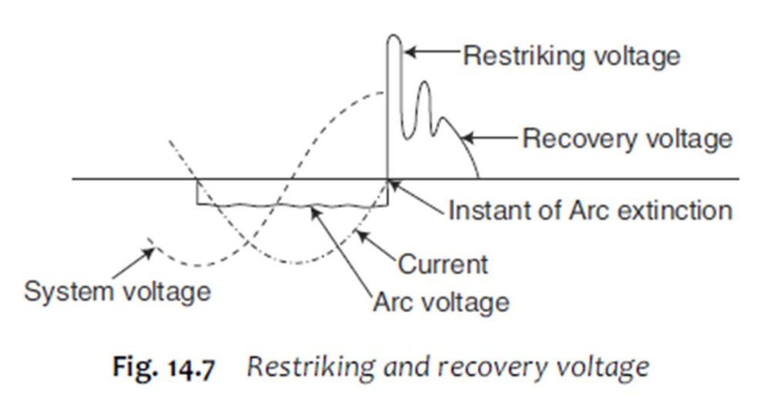
- Theoretical Analysis and Mathematical Expressions
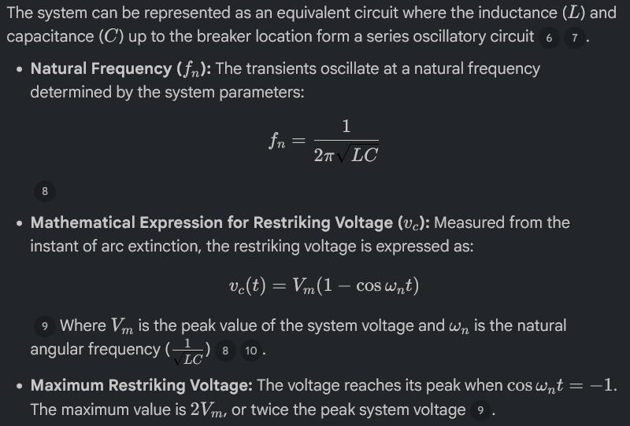
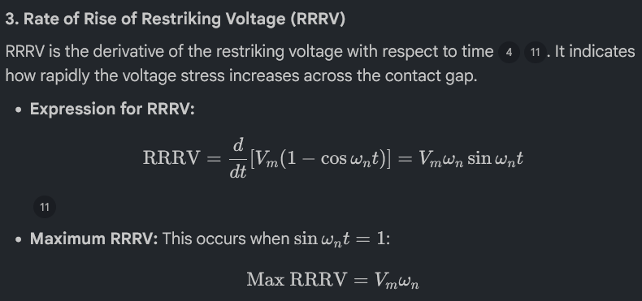
4. Waveform Description:
The complete process is typically visualized in a voltage vs. time graph:
- Arcing Period: Before current zero, a low-magnitude arc voltage exists.
- Transient Period: At current zero, the arc is extinguished, and the voltage suddenly rises and oscillates at the natural frequency (fn). This is the restriking voltage.
- Steady State: Once oscillations subside, the voltage settles into the sinusoidal recovery voltage curve.
5. Significance in Arc Interruption:
The success of circuit breaking depends on the competition between the recovery of the gap's dielectric strength and the RRRV.
- Recovery Rate Theory: For the arc to be permanently extinguished, the dielectric strength of the gap between contacts must recover faster than the restriking voltage rises.
- Failure Condition: If the RRRV exceeds the rate at which the gap's dielectric strength is restored, the gap will break down again, causing the arc to restrike for another half-cycle.
- Severity: Higher natural frequencies result in a higher RRRV, making arc extinction significantly more difficult for the circuit breaker. Resistance switching is often employed to damp these oscillations and reduce RRRV.

2. Explain the working principle, construction, and advantages of SF₆ circuit breakers.
Sulphur hexafluoride (SF₆) circuit breakers utilise SF₆ gas, which possesses excellent insulating and arc-quenching properties, to interrupt electrical currents. These breakers are manufactured for a wide voltage range (3.3 kV to 765 kV) but are predominantly preferred for high-voltage (HV) and extra-high-voltage (EHV) applications of 132 kV and above.

1. Working Principle (Arc Extinction)
The arc extinction process in SF₆ circuit breakers relies on the unique physical and chemical properties of the gas:
- Puffer Action: In modern single-pressure "puffer-type" breakers, the SF₆ gas is mechanically compressed by a moving cylinder system during the contact separation process. This compressed gas is released through a nozzle and directed to flow axially along the arc.
- Axial Cooling: As the gas flows through a convergent-divergent nozzle at near-supersonic speeds, it removes heat from the arc through axial convection and radial dissipation. This rapidly reduces the diameter of the arc as the current approaches zero.
- Electronegativity: SF₆ is an electronegative gas, meaning it has a high affinity for electrons. Free electrons in the arc space are absorbed by neutral SF₆ molecules to form heavy, immobile negative ions, which effectively removes the charge carriers necessary to maintain the arc.
- Rapid Dielectric Recovery: Due to its short thermal time constant and high recombination rate, the gas quickly regains its dielectric strength after the current zero, allowing it to withstand severe Rates of Rise of Restriking Voltage (RRRV) without restriking.
2. Construction
The construction of a standard puffer-type SF₆ circuit breaker includes the following key components:
- Interrupter Unit: Contains a pair of fixed and moving contacts. The moving contact is coupled with a movable cylinder.
- Nozzle: A convergent-divergent nozzle made of insulating material is used to guide the high-pressure gas over the arc.
- Tank Designs: There are two primary structural designs:
  - Live Tank: The interrupters are supported on porcelain insulators.
  - Dead Tank: The interrupters are housed in an earthed metal tank filled with SF₆ gas.
- Auxiliaries: To maintain the gas quality and safety, the construction often includes moisture-absorbing materials like soda lime and activated alumina, as well as thermostatically controlled heaters to prevent gas liquefaction at low temperatures.
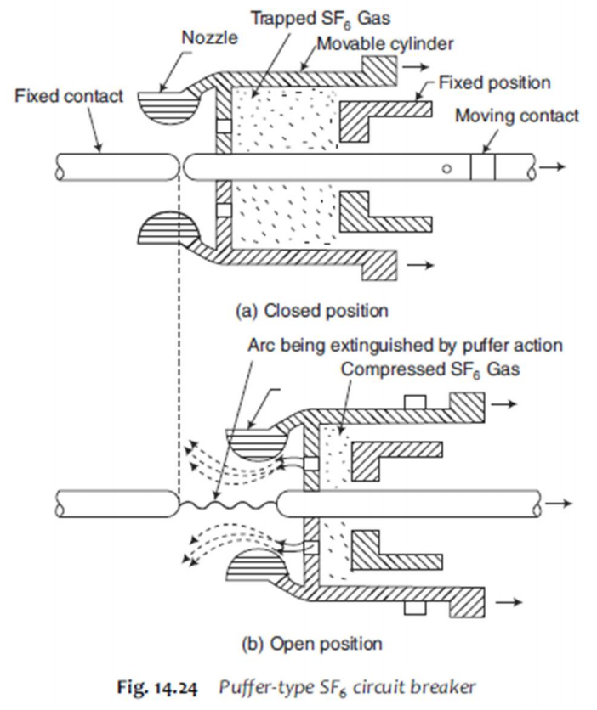
3. Advantages
SF₆ circuit breakers offer several significant benefits over air-blast or oil circuit breakers:
- Compactness: Due to the superior dielectric strength of SF₆ (about 2.35 times that of air), the contact gaps and overall dimensions are much smaller, leading to reduced substation space requirements.
- Safety: The gas is non-inflammable and chemically stable, eliminating the fire and explosion hazards associated with oil circuit breakers.
- Low Maintenance: The chemical inertness of SF₆ reduces contact corrosion and oxidation, while the sealed construction protects internal parts from moisture and dust.
- Performance: They provide short and consistent arcing times, leading to less contact erosion. They are also highly effective at interrupting capacitive currents without restriking and minimise the problem of current chopping.
- Noiseless Operation: Unlike air-blast breakers that exhaust to the atmosphere, SF₆ breakers operate in a closed-cycle system, making them much quieter.

4. Vacuum Circuit Breaker (VCB)
Operating Principle: The vacuum circuit breaker operates on the principle that a high vacuum (pressure of to torr) has superior dielectric strength and arc-interrupting ability compared to other media. In such a high vacuum, the mean free path of residual gas molecules is so large (several metres) that electron avalanches cannot form. When contacts separate, the arc is not supported by the medium but by metallic vapours evaporated from microprojections on the electrode surfaces. As the current approaches zero, the rate of vapour emission decreases, and immediately after current zero, the remaining vapour condenses rapidly on the shields, allowing the gap to regain its dielectric strength at an extremely high rate (up to 20 kV/µs).
Construction (Referencing Fig. 14.25):
- Enclosure: The interrupter is housed in an insulating envelope made of glass, porcelain, or glass-fibre reinforced plastic, which is thoroughly degassed and sealed.
- Contacts: The electrodes are typically disc-shaped and made from specialized materials like copper-bismuth or silver-lead to ensure high breakdown strength. They often feature spiral segments that produce an axial magnetic field to keep the arc moving, preventing local electrode erosion.
- Vapour Shield: A synthetic resin shield is placed between the contacts and the outer envelope to prevent metal vapours from condensing on the insulating walls, which would otherwise compromise the insulation.
- Metallic Bellows: A stainless steel metallic bellows allows the lower contact to move while maintaining a perfect vacuum seal.
- End Flanges: Metal end flanges support the entire structure, including the fixed contact and the bellows assembly.
Merits:
- Compactness and Simplicity: They are smaller and have a simpler construction than other breaker types.

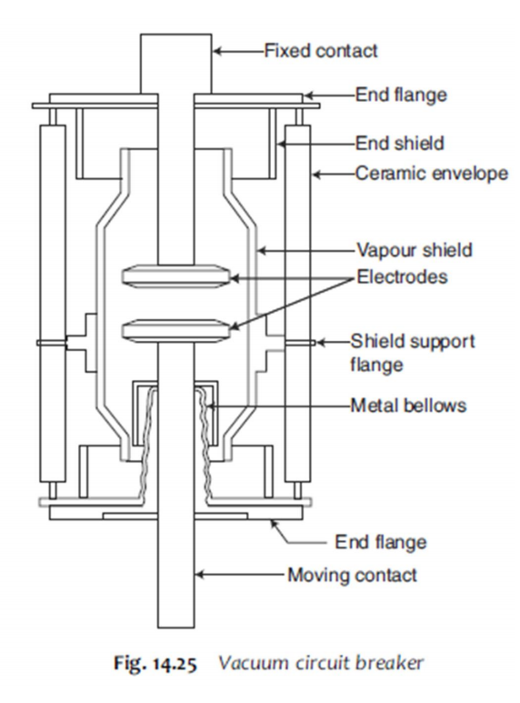
- High Speed Recovery: The extremely fast dielectric recovery makes them highly efficient at interrupting current.
- Low Maintenance: They are essentially maintenance-free and suitable for repeated operations (e.g., in industrial applications).
- Silent and Safe: Operation is virtually silent, and there is no risk of fire or explosion as no oil is used.
- High Performance: They effectively interrupt capacitive and small inductive currents without producing dangerous transient overvoltages.
Limitations:
- Voltage Range: Currently, they are predominantly used for medium voltage applications, typically up to 33 kV or 36 kV.
- Non-repairable Interrupters: Once the vacuum is lost or the interrupter is damaged, the entire unit must usually be replaced rather than repaired at the site.

5. Air Blast Circuit Breaker (ABCB)
Operating Principle: Air blast circuit breakers use compressed air (typically at 20–30 kg/cm²) as the quenching medium. When the contacts separate, a high-pressure blast of air is released, which physically sweeps away the ionised particles in the arc path and rapidly cools the arc, leading to extinction at current zero.
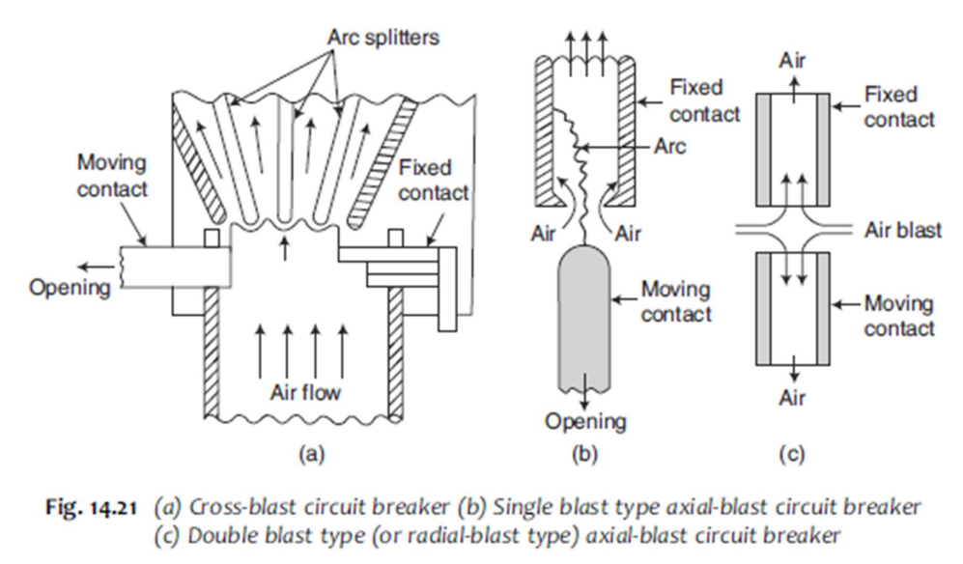
Operational Types and Diagrams (Referencing Fig. 14.21):
- Cross-blast (Fig. 14.21a): The high-pressure air blast is directed perpendicularly across the arc. This forces the arc into an arc chute where it is split and elongated. This adds significant resistance to the arc path, facilitating interruption. These are suitable for high current (up to 100 kA) at lower voltages.
- Axial-blast (Fig. 14.21b & c): The blast is directed longitudinally (in line with the arc). It can be a single blast or a double/radial blast where air flows from both sides toward a central orifice. Axial-blast units are ideal for Extra High Voltage (EHV) systems because the chambers can be easily enclosed in porcelain tubes.
Applications:
- High Voltage Systems: They are primarily used for voltages of 132 kV and above, including super-high voltage applications up to 1100 kV.
- Frequent Switching: Due to their fast operation and short arcing times, they are used where frequent operations and high-speed reclosure are required.
- Heavy Duty: They handle breaking capacities ranging from 10,000 MVA at 132 kV to 60,000 MVA at 750 kV.
Merits and Demerits:
- Merits:
  - The medium (air) is free, chemically stable, and non-inflammable, eliminating fire hazards.
  - They offer short and consistent arcing times, resulting in minimal contact erosion and less maintenance.
  - High-speed operation makes them excellent for maintaining system stability.
- Demerits:
  - Complexity: They require an expensive and high-maintenance air compressor plant.
  - Noise: The discharge of high-pressure air to the atmosphere creates significant noise, often necessitating silencers in residential areas.
  - Switching Issues: They are susceptible to current chopping and sensitive to the Rate of Rise of Restriking Voltage (RRRV), often requiring parallel resistors to mitigate these effects.

